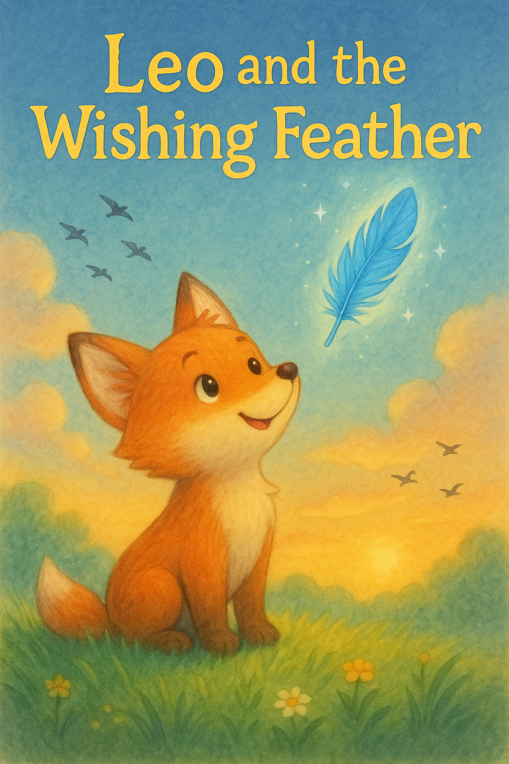

Leo was a little fox who loved to chase butterflies and roll in the grass. But what he wanted most in the world was to fly like the birds.

Every morning, he’d watch the robins flap and soar above the forest trees, and he’d sigh, “If only I had wings!”

One day, while walking near the river, Leo found a bright blue feather shimmering in the sunlight. It glowed gently, like it had a secret.

A small voice whispered from the wind,   
“I’m a wishing feather. Make a wish from the heart.”  
Leo closed his eyes and whispered,   
“I wish to fly, even just once.”

Suddenly, the feather spun around him, faster and faster, until it lifted Leo into the sky!   
He zoomed past clouds and dipped through sunbeams, his fur glowing golden in the light.

He laughed and flipped and fluttered,   
just like a bird.

But then he heard a soft meow from below.   
It was Mia the kitten, stuck at the top of a tree, too scared to come down.

Leo swooped down and gently   
grabbed a branch with his teeth,   
nudging Mia toward safety.

“you saved me!” Mia purred as the glowing feather drifted to the ground. “Even if I never fly again, I used my wish to help.” Said Leo. From then on, Leo preferred walking with Mia and sharing tales of his flight, when the wind was right, the feather would glimmer once more.

The End.